Sign in to the Powerapps.microsoft.com

Click on the App Form Left Navigation Menu On the Screen.

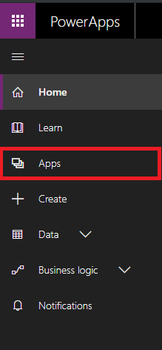

You’ll be redirected to the Apps Page Where you have List of your Applications. Click on “Import Package(Preview)” For Upload solution.



On the Import Page Click on the Upload button, Upload the Given Solution in GitHub as “zip”.

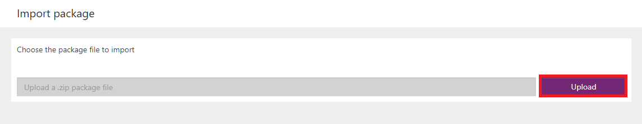

After few Second we’ll have all the Configuration details of the PowerApps and Flow.

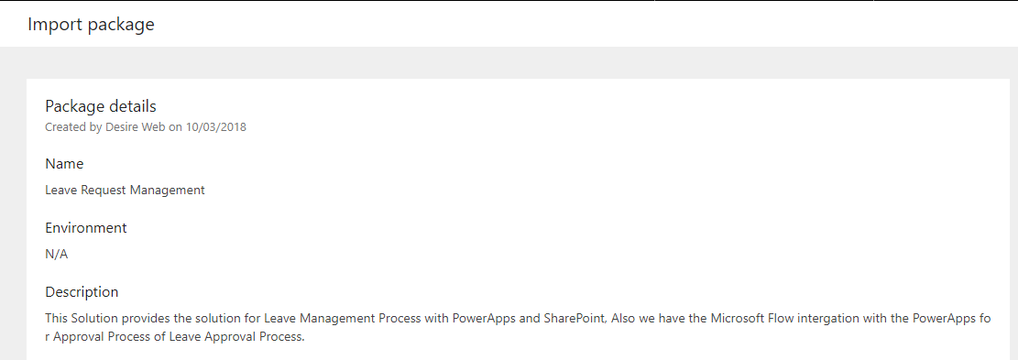

Now As you Scroll down there are Details of the PowerApps and Flow

Like below here we can change the Name of the PowerApp Application or the Flow, and also you have to select the User Connection who is the Author of the PowerApp and Microsoft Flow.

After Configure click on the

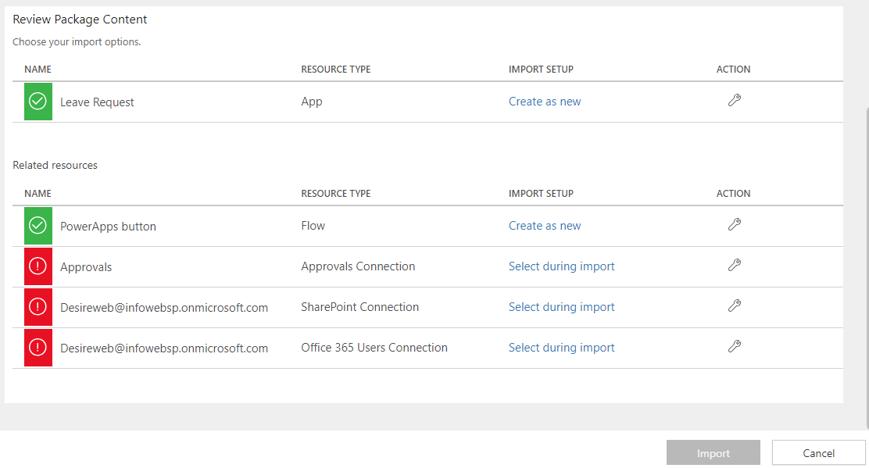

Configure the PowerApp and Flow

Click on the Create as New for Change the Name of the PowerApp in your Organization.

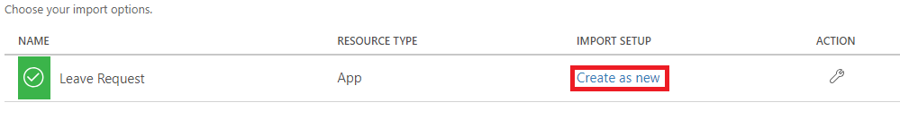

There will be Side menu on the Screen, you can change the Name by typing new Name in the Highlighted box in below image and Click Save.

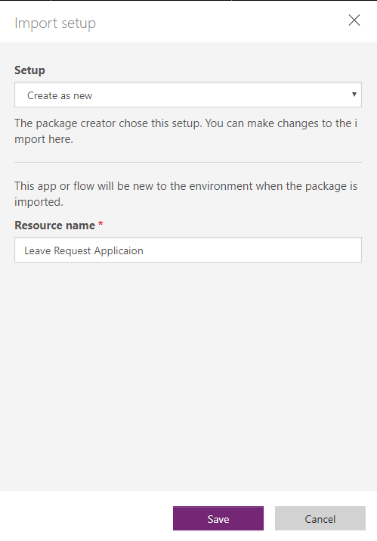

Same as the PowerApp into the Microsoft Flow if you want to update the Name Of the Flow you can With below Steps

Step 1: Click on the Create As New



Step 2: Than On the side menu Enter the Name you want and Save it.

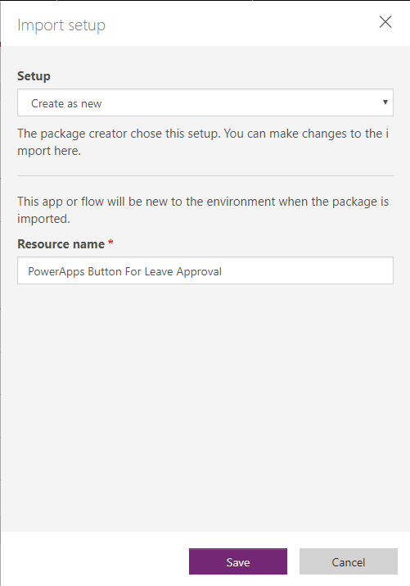

Then in next steps we have to Provide the Connectors for Approval Process, SharePoint Connection and Office 365 User Connector.

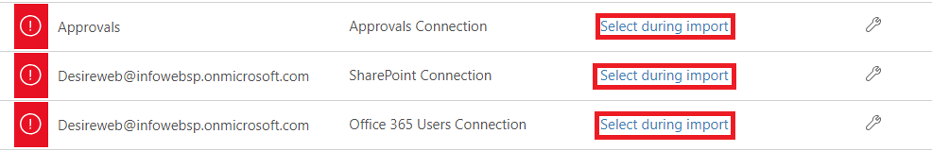

The Configuration Steps for both of them are same.

Step 1: Click on the Select during Import

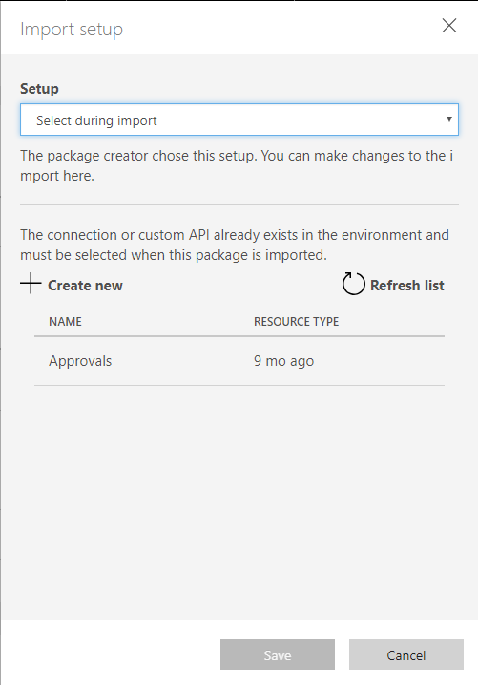

Step 2: Select Form the list of the Connectors, If in case you don’t have you can create form Create New button. And after that click on the Save button.

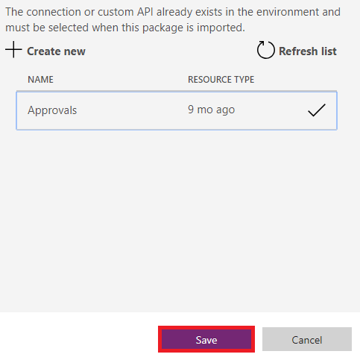

As now you can see the Import Button will be Activated after all the Configuration Completed. And as you can see there will be users Id also into the SharePoint Connection and Office 365 Users Connection.

Click on the Import.

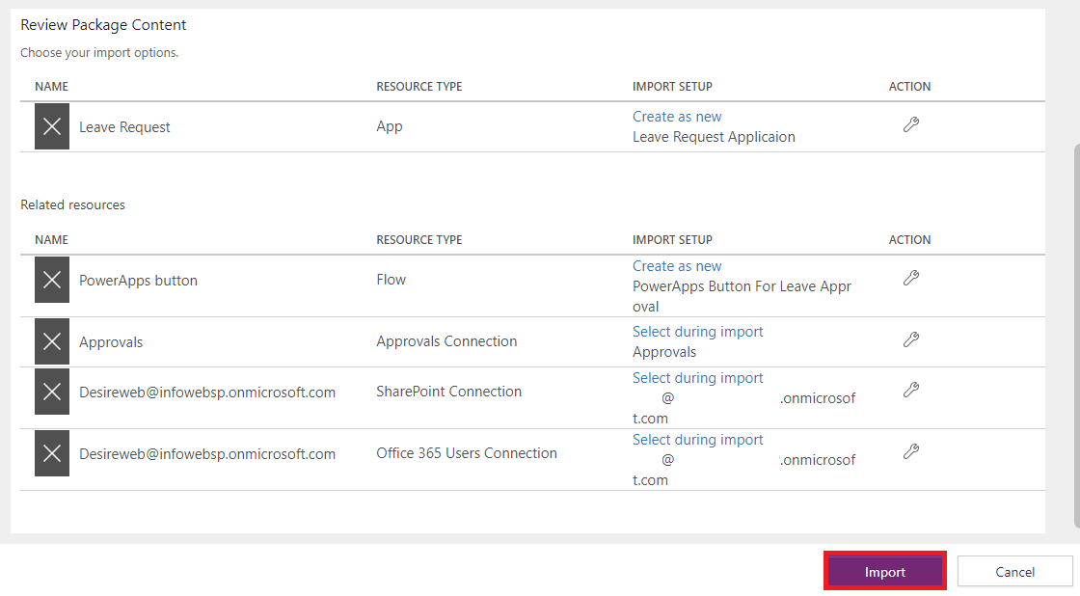

After Few Seconds you’ll have the Success Message like below

